

RAPPORT DE STAGE

JEAN-LUC TWITE ILUNGA
DU 20 decembre 2025 au 31 Mars 2026

Superviseure de stage: Mr. Raphael Dipa
Entreprise D’accueille: Frontier Mining.

SOMMAIRE

DEDICASE ET REMERCIEMENT
INTRODUCTION
Chapitre 1 : GENERALITES SUR UN SYSTEM CCTV
Chapitre 2 : GENERALITES SUR UN ENVIRONMENT DE RESEAU INFORMATIQUE
Chapitre 3 : GENERALITES SUR UN SYSTEM DE CONTROLE D’ACCESS
Chapitre 4 : IT SUPPORT
Chapitre 2 : CONCLUSION

REMERCIEMENT
I would to say thank you to the brillante, intelligent and hardworking people which is Frontier IT department teams especially to MR PATRICK UMBA for giving me this internship opportunity

INTRODUCTION
This report presents an overview of the knowledge and practical skills I have acquired since I started my Internship at ERG Africa – Frontier Mine in IT department. The objective of this report is to clearly describe the hands-on activities I have participated in, and my understanding of the IT infrastructure used within the mine environment. That will help me to grow in the IT field and build strong skills that will help me in my Future professional career.
Je Souhaite Travailler dans le secteur de l’IT, il m’a parrus il m'a donc paru essentiel d'avoir une experience plus poussee dans les domaines de IT. C'est dans cette optique que j'ai effectue mon stage dans la societe ERG Africa-Frontier Mine.

1.GENERALITES SUR UN SYSTEM CCTV
1.1 DEFINITION D’UN System CCTV
Closed-circuit television (CCTV), also known as video surveillance, is the use of closed-circuit television cameras to transmit a signal to a specific place on a limited set of monitors.
1.2 UTILITER D’UN SYSTEM DE CCTV
The cctv’s system is mostly used for:
- Crime prevention
- Traffic flow monitoring
- Operational & Staff Management
1.3 Skills learn about the cctv’s system
I have always seen cctv cameras on most of the buidings this can be schools, houses, and bigger, big companies and etc.. but I always wanted to know what exactly happening behind or in the background of it.
With Mr Heritier shimba I have been introduced to the cctv’s system and that was my first time an hands on when it comes to cctv, The first things he teach me to always clean the camera when they gate dirty then after. We were tasked with cleaning CCTV cameras installed in different locations.
We then repair a CCTV camera. He explained that most the issues we got was related to a PoE (Power over Ethernet) adapter, which was supplying power to the camera but not network connectivity.
He gave me brief architecture of the cctv’s system, and I also learn the type of camera we mostly used at frontier which are:
- PTZ (Pan, Tilt, and Zoom) cameras: are the type of camera than can move horizontally, vertically and zoom in or out remotely
- ANPR(Automatic number plate recignition) Cameras: Those are cameras that uses optical characterrecogniion to automatically read, log, and store vehicle license plate numbers in real time.
- Bullet Cameras: those are fixed-position surveillance cameras designed for long-distance viewing they are mostly used for outoor and ,monitoring.
With Mr Heritier I had the opportunity to install all those type of cameras I just mentioned I had also the opportunity to install an ANPR cameras at the weight bridge well it was quite challenging for me.
As for the challenge I encounter was for the Cablage part I had to do a good cablage but with more reflection I did manage to do a Good cablage.

Mr Heritier explained to me the architecture of CCTV system here is small figure of the System

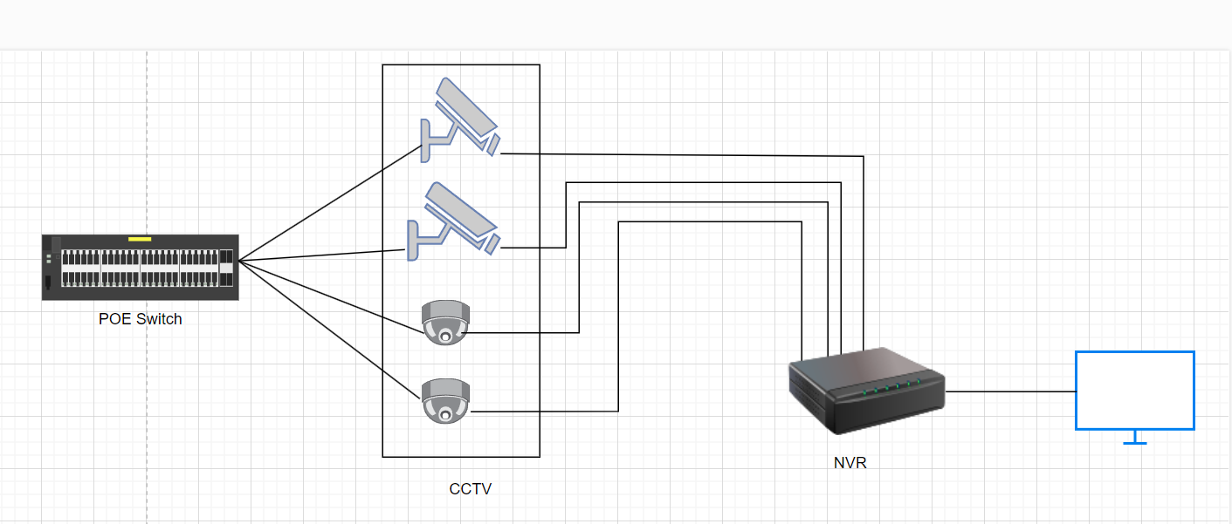
Explaination:

- Poe switch power + connects cameras
- Cameras sends video to the NVR (Network video Recording)
- NVRStore and Share videos
- Monitor connect to NVR to view
Remarque:
I would like to advice the cctv team if possible the get the necessary materials to clean the cameras those materiel must keep somewhere in the office cause we were washing the camera using gloves this has touch my heart and it something I wanted to share with the CCTV team.

Conclusion:
I have learned a lot about the CCTV’s system My time with the cctv’s powered up my skills when it comes to cctv I know there are still a lot thing to know about the system but with the knowledged I acquired I am sure this help me in my future camera.
Thank you so much to Mr Heritier Shimba Alias El sepekenio.

2.GENERALITES SUR UN ENVIRONMENT RESEAU INFORMATIQUE

2.1 DEFINITION D’UN RESEAU INFORMATIQUE
a network is a group of computers and other devices (such as printers) that are connected by some type of transmission media. Variations on the elements of a network and the way it is designed, however, are nearly infinite. A network can be as small as two computers connected by a cable in a home office or the most complex network of all, the Internet, made up of billions of computers and other devices connected across the world via a combination of cable, phone lines, and wireless links.

Fundamentals OF Networking.:
While interning with the network team, I learnt the basics of network connection: When computers establish a connection with each other, they need an Internet IP address. I discovered the significance of IP addressing in device name recognition and between-device communication. I also learned the distinction between MAC addresses and IP addresses, that when it comes to hardware-level network interfaces, MAC addresses are in fact for identifying network inter, while IP addresses are for logical communication within and across networks. Plus, I discovered what the difference is between:
• LAN (Local Area Network): Used to connect devices within the same site or location
• WAN (Wide Area Network): Used to connect networks across long distances and to the internet

2.2 VLANs (Virtual Local Area Networks)

I was introduced to the concept of VLANs and learned how they are used to logically separate network traffic within the same physical network. I learned that VLANs improve security, performance, and network organization by isolating different departments or services (such as IT, HR, CCTV, and access control) while using the same physical infrastructure.

2.3 Network Cabling
I gained hands-on experience wiring and testing UTP (Unshielded Twisted Pair) cables. This included identifying faulty cables, replacing damaged cables, and ensuring proper termination for reliable connectivity. I was also introduced to fiber optic cables, including their purpose in long-distance communication. I learned the basics of fiber optic splicing and understood why fiber is preferred for backbone and inter-building connections due to its high-speed, long-distance capability, and resistance to interference.

2.4 Network Devices
I learned the function and importance of network devices such as:
• Switches: Used to connect multiple devices within a LAN
• Core switch: Acts as the backbone of the network and connects all distribution and access switches, enabling high-speed communication between systems
• Difference between manageable and non-manageable switches and why manageable switches are required for VLAN configuration
I was also exposed to installing operating systems over the network, which helped me understand how network services support system deployment and configuration.

The Enterprise Resource Plan ERG Frontier Network Infrastructure. The network infrastructure used at ERG Frontier Mine caters to specific operations such as critical mining, office systems, security systems, and remote departments. 3.1 Local Area Network (LAN) is a network connected through two main connections: IP. The core switch is the network backbone - it functions as the LAN in this system. The core switch connects to distribution and access switches that are present in various departments. This design facilitates communication between all site systems quickly and reliably. 3.2 Wide Area Network (WAN) & Internet Connectivity WAN connects ERG Frontier Mine to the internet as well as external services. The site uses two Internet Service Providers:
• Liquid Telecom (primary connection)
• Orange (backup connection)
Liquid takes precedence for normal operations and Orange is used as a failover connection when the primary link is not available. 3.3 Wireless and External Connectivity Antennas transmit and receive network traffic from these remote offices to the central network. They also act as wireless links to connect remote locations, which cannot be done if the cabling is fiber or copper. Network Security – firewall. A firewall is added between the internet/WAN external network and the internal LAN. The firewall is the unit of a network which is able to secure the organization of information by sniffing data coming and going while allowing or excluding data according to security rules. Ensures that only permitted and safe traffic is allowed through an ERG network. A small architectural architecture of erg network is shown below.

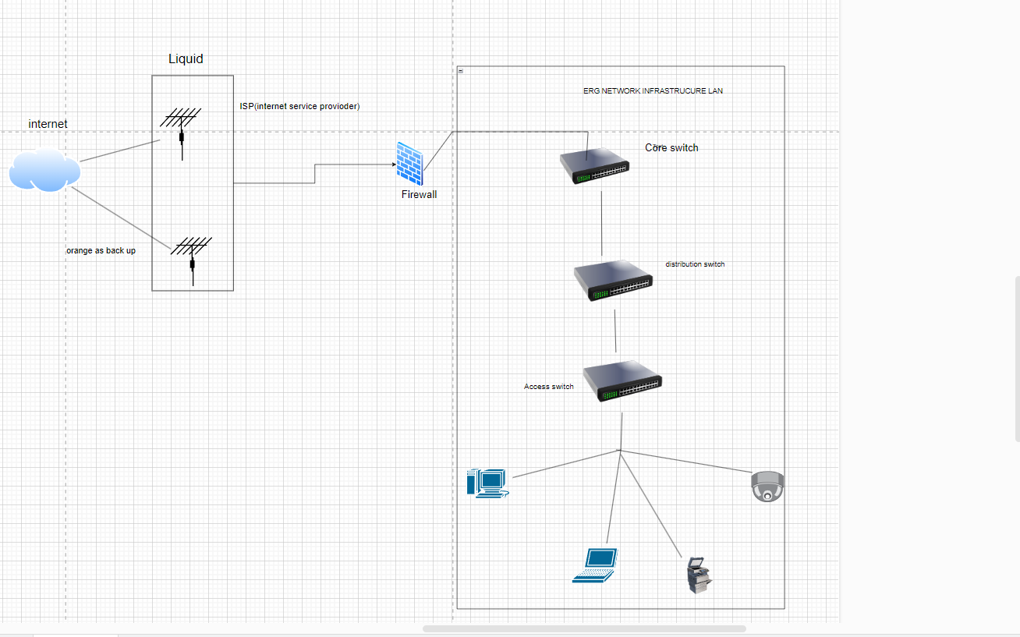

2.4. Practical Experience Gained
On the network team:
• Wiring and replacing UTP cables
• Troubleshooting network connectivity issues
• Assisting with fiber optic splicing activities
• Configuring and testing switches
• Understanding VLAN implementation
• Observing and learning network security practices

2.5. Conclusion
My work with Frontier Mine networking team has provided me practical, in-depth lessons, which is one such experience I think has really solidified the basics on networking. I learned about how enterprise and industrial networks are designed, implemented and maintained in a mining context. This internship helped me improve my technical skills and problem-solving skills and has been very motivating and motivated me to get into the domain of networking or data based studies. I am confident that the skills that I gained now should help me in the future.

3.GENERALITES SUR UN SYSTEM D’ACCESS CONTROLE

3.1 DEFINITION D’UN RESEAU INFORMATIQUE
An access control system is a security solution that manages and monitors entry to physical spaces (buildings, rooms) or digital resources. It uses electronic components—such as card readers, keypads, or biometric scanners—to verify identities and grant or deny access based on authorized permissions.

3,2 Component of an access control System

- Credentials: it something that users carries or knows like a key card, PIN, or smartphone app,
- Readers: those are devices at the entry point that scan the credentials
- Controller: The brain that checks authorized access
- Locking Mechanism: electronics locks such maglocks or doors strikes

3.3 How The access control system works
When a person presents a credential (e.g., swiping a card), the reader sends the information to the control panel, which validates it against a database. If authorized, the system unlocks the door and logs the activity (who entered and when). This provides a secure, audited alternative to traditional keys.
With the time I spend with Mr Sebastien Kanda he explained to me that at Frontier mining we mostly used the Badges of proximity So when we firstly badges there is a magnetic champ happening between the reader device and the badge or card then the reader send electric signal to the Maglock and then unlock the doors inside the maglock we have what we call a Solenoid that convert the electric into a champ magnetic which allow the maglock to unlock the door.

I had the opportunity to work close with Mr Sebastien on UTP (Unshielded Twisted Pair) cabling for access control reader devices. The task was challenging for me at first, but with guidance and assistance from Mr Sebastien, we were able to successfully complete the cabling.
Mr Sebastien terminated the first UTP cable and then allowed me to terminate the second one. Although I experienced some difficulty, he assisted me and explained the correct steps, which helped me improve my understanding of UTP cabling.
We encountered issues with the connectors when connecting them to the switch. After the break, we returned to the MCK department and used a short UTP cable to test the reader devices. This test confirmed that the readers were operational.
After further analysis, we identified that two readers needed to be powered, but only one PoE (Power over Ethernet) injector was functioning properly, while the second PoE injector was damaged. We identified a temporary solution that allowed both readers at the MCK department to operate correctly.

We then go to fixed one reader at the finance main gate which was not working properly we seem that the maglock was working after fixing it we also go to the sakania main gate to remove 3 readers and put new ones which was not working properly after removing we needed to do the addressage and do some synchronisation.

Then we have been given a task to go and fix some doors at the procurement I had the chance to assis the team of papa jimmy from who I learned how to install a maglock on a doors.

3.4 Conclusion
I have learned a lot about the access control ’s system My time with Mr Sebastien powered up my skills when it comes to it I know there are still a lot thing to know about the system but with the knowledge I acquired I am sure this help me in my future career as an access control engineer.
Thank you Mr Sebastien and I really want to go further with the access control system and strengthen my skills as times go
4 IT Support
During my internship as an IT support I was asked to help our users by Installing The application named Ivanti which is created work profile for them, I encounter a lot of challenge with the app but as time goes I will definitely mastered it and I was also mostly send to set up new desktop computers and monitors for users, with Mr miles I got the opportunity to do a new system on users’ computers, I assisted mr Raphael diba on the repair on a printer and I also assist him by getting an inventories on computers we have on site I am still continue with the list and I hope I will be able to get all the computer’s details listed

5.CONCLUTION
I have always wanted to work in a big corporate company like Erg Frontier-Mine with a background in Software development, Data engineering, and Devops engineering. I always knew that there is more to learn in IT worldwide I am passionate about getting to know new things and face new challenges.
At Frontier mine I have been expose to new thinks which I have always wanted to understand or make path of my career journey I have been expose to CCTV System, Physical networking, Access Controle System and finally IT support, Among all of these I Mostly Interested in Access control and CCTV systems those are two career that catch my intention the most but I have to make a choose I will definitely going for access control system. I am still on my journey on learning it and I will do my best to master and become a pro or a senior into that field I got a well Skills mentor who is Mr Sebastien Kanda and I have no doubt that I will master the Access control system.
I really enjoyed my time with the IT teams, and I am sure with the skills I acquired from you guys this will put me ahead in the IT field all over the places, I am wishing the team all the best and don’t forget to always work safely.
As advice I would to tell the IT teams in the program sheet there are column named commentary and duree those are always empty let fill it in the commentary column let update it according to the task that has been assigned and in the durée column let put how the task has been take to finish then if we not going to use it let remove those two columns from the sheet

